

**Western Australian Certificate of Education**

**ATAR course examination, 2018**

**Question/Answer Booklet**

12 PHYSICS

Name

**Test 2 - Motion and Gravitation**

|  |  |  |  |  |  |  |  |  |  |  |
| --- | --- | --- | --- | --- | --- | --- | --- | --- | --- | --- |
| Student Number: In figures |  |  |  |  |  |  |  |  |  |  |

**Mark: $\frac{}{\text{55}}$**  In words

#### Time allowed for this paper

Reading time before commencing work: five minutes

Working time for paper: fifty-five minutes

**Materials required/recommended for this paper**

To be provided by the supervisor

This Question/Answer Booklet

Formulae and Data Booklet

***To be provided by the candidate***

Standard items: pens, (blue/black preferred), pencils (including coloured), sharpener, correction fluid/tape, eraser, ruler, highlighters

Special items: non-programmable calculators satisfying the conditions set by the School Curriculum and Standards Authority for this course

**Important note to candidates**

No other items may be taken into the examination room. It is your responsibility to ensure that you do not have any unauthorised notes or other items of a non-personal nature in the examination room. If you have any unauthorised material with you, hand it to the supervisor before reading any further.

**Structure of this paper**

|  |  |  |  |  |  |
| --- | --- | --- | --- | --- | --- |
| Section | Number of questions available | Number of questions to be answered | Suggested working time  (minutes) | Marks available | Percentage of exam |
| Section One:  Short Answers | - | - | - |  |  |
| Section Two:  Problem-solving | 8 | 8 | 55 | 55 | 100 |
| Section Three:  Comprehension | - | - | - | - | - |
|  |  |  |  | **Total** | 100 |

**Instructions to candidates**

1. The rules for the conduct of examinations at Holy Cross College are detailed in the College Examination Policy*.* Sitting this examination implies that you agree to abide by these rules.

2. Write your answers in this Question/Answer Booklet.

3. Working or reasoning should be clearly shown when calculating or estimating answers.

4. You must be careful to confine your responses to the specific questions asked and to follow any instructions that are specific to a particular question.

5. Spare pages are included at the end of this booklet. They can be used for planning your

responses and/or as additional space if required to continue an answer.

• Planning: If you use the spare pages for planning, indicate this clearly at the top of the page.

• Continuing an answer: If you need to use the space to continue an answer, indicate in the original answer space where the answer is continued, i.e. give the page number. Fill in the number of the question(s) that you are continuing to answer at the top of the page.

6. Answers to questions involving calculations should be ***evaluated and given in decimal***

***form*.** It is suggested that you quote all answers to ***three significant figures***, with the

exception of questions for which estimates are required. Despite an incorrect final result, credit may be obtained for method and working, providing these are ***clearly and legibly set out***.

7. Questions containing the instruction "estimate" may give insufficient numerical data for their solution. Students should provide appropriate figures to enable an approximate solution to be obtained. Give final answers to a maximum of two significant figures and include appropriate units where applicable.

8. Note that when an answer is a vector quantity, it must be given with magnitude and direction.

9. In all calculations, units must be consistent throughout your working.

1. A car is moving at a constant speed around a flat circular track. Which of the following options (A, B, C or D) best describes the velocity, acceleration and net force acting on the car? (Circle your answer.) [1 mark]

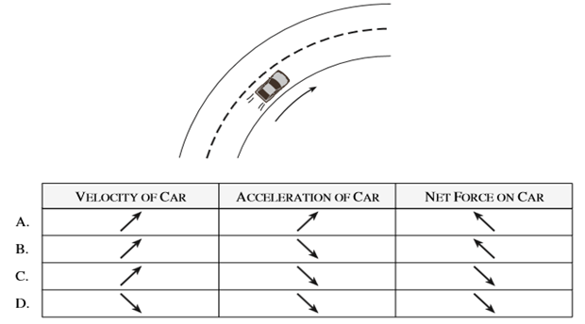

2. A 0.150 kg toy airplane is suspended on a string and is travelling in a horizontal circle at a constant speed as shown in the diagram to the right.

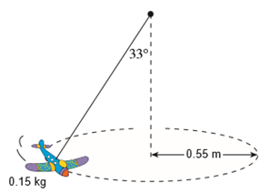

(a) What is its centripetal force? [ 4 marks ]

(b) What is the period of its motion? [5 marks]

(c) Calculate the tension in the rope when the toy airplane is flying on the ***Moon*** in exactly the same pattern as shown in the diagram in part (a). [4 marks]



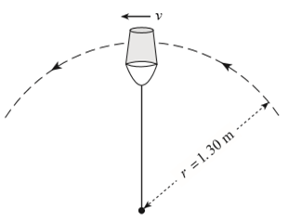3. A physics student swings a 0.500 kg pail of water in a vertical circle of radius 1.30 m as shown in the diagram to the right.

(a) What is the minimum speed (vmin) at the top of the circle if the water is not to spill from the pail? [3 marks]

(b) If the velocity increases so that the bottom of the pail exerts a normal force of 2.45 N on the water when it is on the top of the swing, what is the pail's new velocity?

[4 marks]

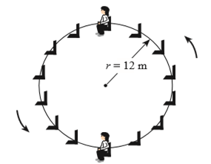4. The diagram to the right shows a 52.0 kg child riding on a Ferris wheel of radius 12.0 m and period 18.0 s.

(a) What is the apparent weight of the child at the top of the ride? [5 marks]

(b) What is the apparent weight of the child at the bottom of the ride? [4 marks]

5. A bicycle and its rider have a total mass of 85.0 kg and travel around a circular banked track at a radius of 20.0 m and at a constant speed of 10.0 ms-1, as shown in Figure 1 below. The track is banked and there is no sideways friction force applied by the track on the wheels.

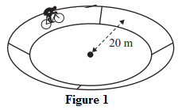

(a) Draw on the diagram below the forces acting on the bicycle. Make sure to label your force vectors. Do not show any nett or component forces. [2 marks]

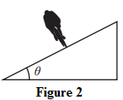

(b) Calculate the correct angle of the bank needed for the riders to travel at 10.0 ms-1 at a radius of 20.0 m, if we assume friction is not contributing to the centripetal force.

[4 marks]

6. Explain the difference between apparent weightlessness and zero gravity, giving examples where each could occur. [4 marks]

7. An 8.87x104 kg satellite is orbiting the Earth at an altitude of 7.00 x 102 km. Assume the satellite is in a stable orbit.

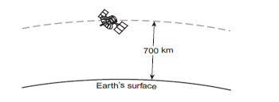

What is the orbital speed of this satellite? [4 marks]

8. (a) Derive Kepler’s third law. Your derivation must start with two forces. [3 marks]

Use the diagram below to answer parts (b) and (c) of this question. Please note the area sectors labelled Area 1 and 2 are equal areas. Use Kepler’s Laws to answer the questions below about this diagram.

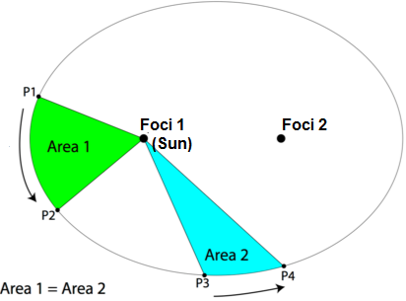

(b) Compare the velocity of the object as it moves from P1 to P2 versus when it moves from P3 to P4. Explain why the velocities are different or similar. [2 marks]

(c) Compare the time taken for the object to move from P1 to P2 versus the time to move from P3 to P4. State which of Kepler’s Laws you applied to answer this question. [2 marks]

9. If the period of a satellite orbiting the Earth is 36.0 hours, what is the orbital radius (radial distance from the centre of the Earth) for this satellite? [4 marks]